Start Visual Studio and select **New Project** from the **Start** page. Or, from the **File** menu, select **New** and then **Project**.

In the **Templates** pane, select **Installed Templates** and expand the **Visual C#** node. Under **Visual C#**, select **Web**. In the list of project templates, select **ASP.NET Web Application**. Name the project "ProductsApp" and click **OK**.

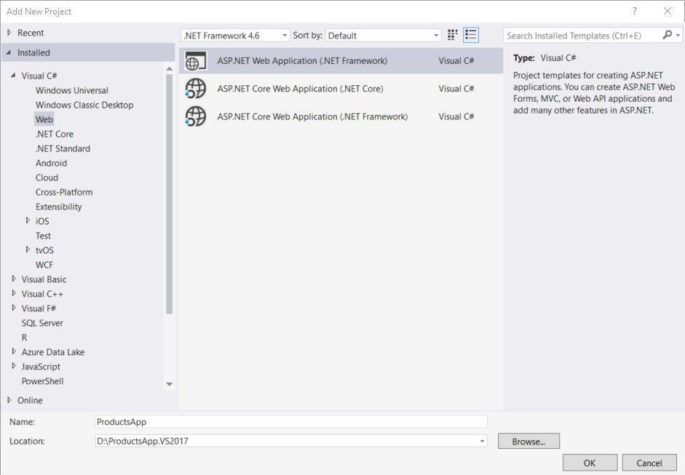

In the **New ASP.NET Project** dialog, select the **Empty** template. Under "Add folders and core references for", check **Web API**. Click **OK**.

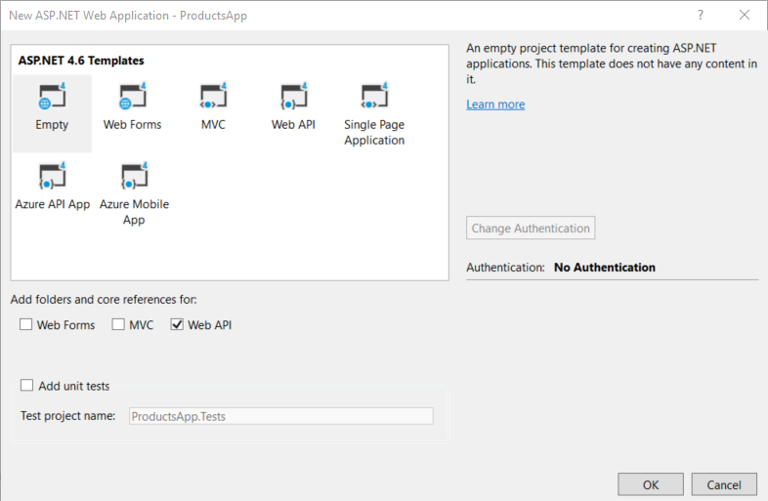

**Note**

You can also create a Web API project using the "Web API" template. The Web API template uses ASP.NET MVC to provide API help pages. I'm using the Empty template for this tutorial because I want to show Web API without MVC. In general, you don't need to know ASP.NET MVC to use Web API.

**SWASHBUCKLE**

* **Download load the Nuget Package and build and Run the project**
* **Go to the following Link** [http://localhost:<PortNumber>/swagger/ui/index](http://localhost:%3cPortNumber%3e/swagger/ui/index)

**Eg** <http://localhost:8813/swagger/ui/index>

A Web API controller action can return any of the following:

1. void
2. **HttpResponseMessage**
3. **IHttpActionResult**
4. Some other type

Depending on which of these is returned, Web API uses a different mechanism to create the HTTP response.

| **Return type** | **How Web API creates the response** |
| --- | --- |
| Void | Return empty 204 (No Content) |
| **HttpResponseMessage** | Convert directly to an HTTP response message. |
| **IHttpActionResult** | Call **ExecuteAsync** to create an **HttpResponseMessage**, then convert to an HTTP response message. |
| Other type | Write the serialized return value into the response body; return 200 (OK). |

**void**

If the return type is void, Web API simply returns an empty HTTP response with status code 204 (No Content).